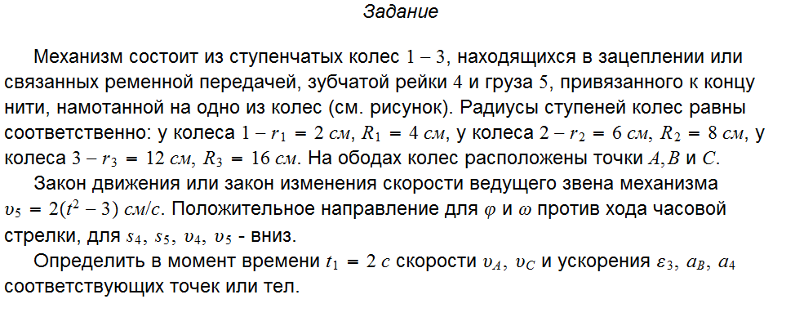
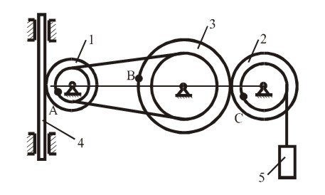

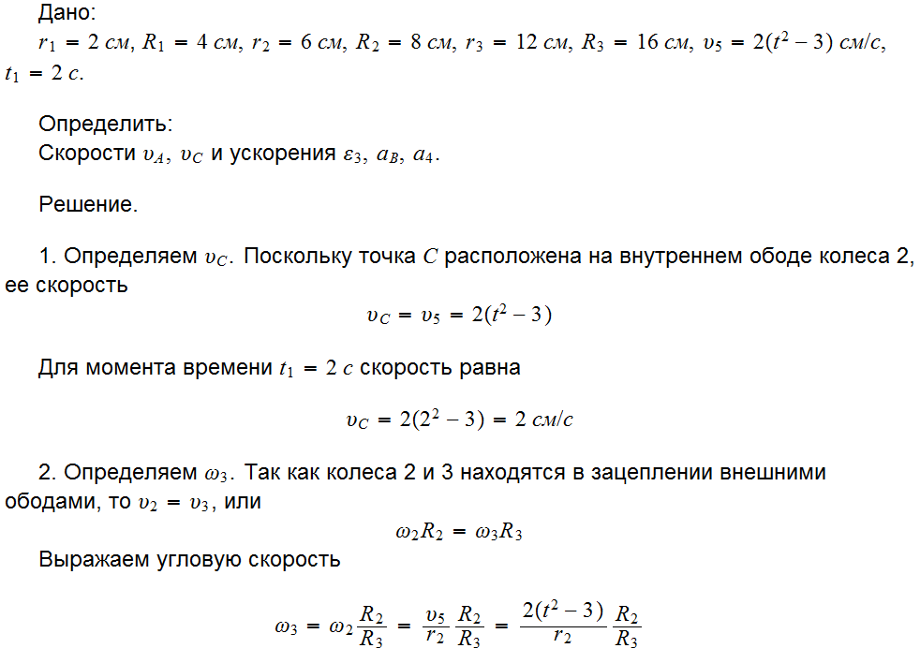

5
4
2
3
1
ω₁
ω₂
ω₃
υ ₅
υ ₂ = υ ₃
a_{Bτ}
a_{Bn}
a₅
a
υ₄
B
A
υ _{A}
C
υ_{C}

